Vind die 3 baba gesiggies en die 3 ladybirds
http://www.playbuzz.com/globalcontentltd11/find-the-hidden-objects-in-these-photos#!#sixtieth
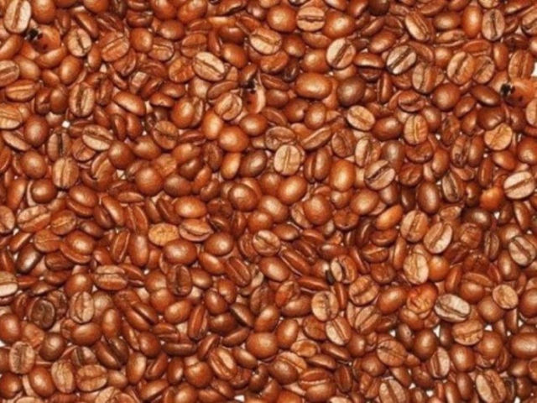

ANTWOORD:
