Vind die aartappel
http://www.sun-gazing.com/quiz-can-find-hidden-objects-pictures-find/


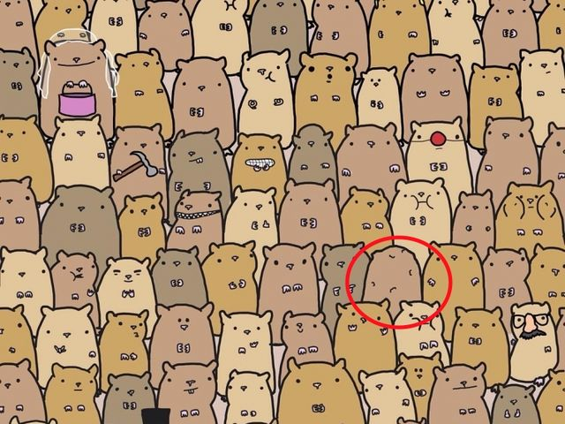
ANTWOORD:

