Vind die vier blaar ‘clover’
http://www.playbuzz.com/richardmahoney10/can-you-spot-the-four-leaf-clover

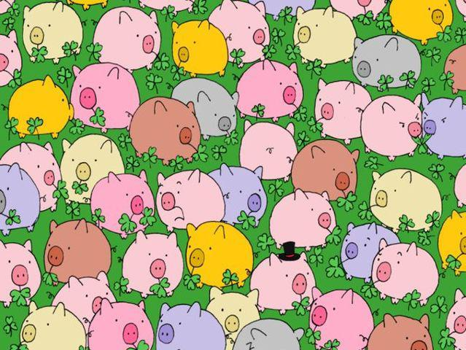

ANTWOORD:

