A Guide for Parents

Must my child wear a mask?

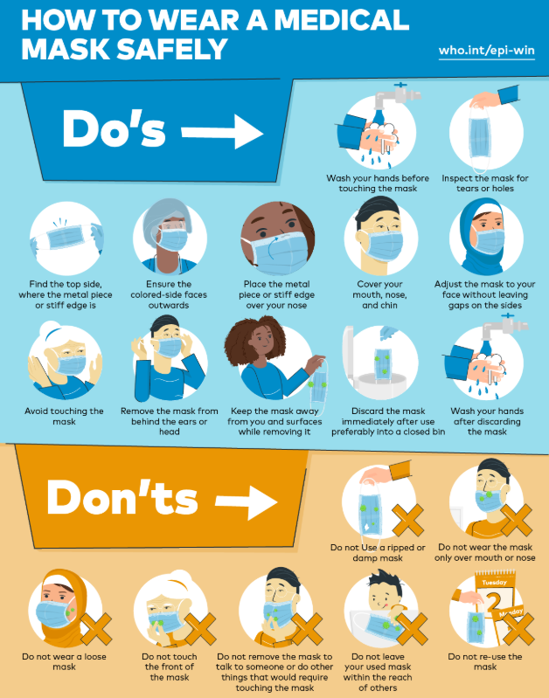
COVID-19 regulations stipulate that a person leaving their home shall wear a mask. It is compulsory to wear a mask at school. Wearing a mask is not comfortable; for that reason the appeal is to parents to have their children practise wearing a mask for extended periods at home. Knowing what to do and what is unacceptable is vital.

When must my child stay at home?

Every learner should be kept at home when he/she presents any of the following COVID-19 symptoms:
Typical Covid-19 Symptoms | Yes/No
Fever
Cough
Bloodshot or red eyes
Difficulty in breathing
Body pain
Physical weakness and fatigue
Loss of taste or smell
Nausea
Vomiting

What happens when the learner arrives at school?

- A medical screening of the learner will take place. This means:
  - Taking the temperature of the learner with an appropriate instrument;
  - Completing a questionnaire that may include the symptoms the learner could be presenting.
- Supervision and monitoring of physical distancing of at least one-and-a-half metres between learners.

What happens when a learner presents typical Covid-19 symptoms?

- The learner will be denied access to the school premises and the parent / guardian will be required to return the learner to their home.
- Should the learner be at school when he / she presents Covid19 symptoms, he / she will be isolated to prevent any danger to any other learners or to members of staff.
- If the learner is not wearing a face mask, he / she will be issued with one.
- The parents / guardians of the learner will immediately be informed of the situation.
- The school will inform the appropriate health official or contact the COVID help line at 0800-02-9999.

Is taking the temperature compulsory?

The Constitution guarantees all people the right to privacy and bodily integrity. Section 36 of the Constitution allows for the limitation of these rights as long as the limitation is reasonable and legitimate.

There can be no doubt that Covid-19 is exceptionally contagious. This highly contagious nature and the global mortality rate necessitate a limitation of the rights to privacy and bodily integrity. The limitation allows Health and Safety measures and schools’ risk management measures. These measures may involve the taking of learners’ temperatures.

There can be no reasonable objection to the taking of temperatures as long as the process is not unnecessarily intrusive. Were the taking of temperatures to be refused, it would still be possible to do a medical screening process to allow schools to comply with the Health and Safety regulations. Any person refusing to allow his / her temperature to be taken may legitimately be refused access to the school premises.

What about the tuck shop?

Government Gazette 43258 of 29 April 2020 states that specified business may, under strict conditions, gradually be allowed to open. Level 3 regulations have yet to be published so Level 4 regulations are applicable. These regulations require the following:
(a) hygiene measures and social distancing must be strictly observed;
(b) job specifications and workers must be phased in to ensure Covid-19 readiness;
(c) returning to the workplace must be managed in such a way as to ensure that the risk of infection remains low.
Tuck shops fall into the category of businesses indicated for opening. They may therefore sell only such products as allowed by the regulations. Foodstuffs may be sold. Cooked food may be sold only if delivered directly to the buyer’s residence.

Tuck Shops may be opened as long as they comply with the regulations. Social distancing must be enforced. Surfaces must be sanitised regularly. Ensure that hand sanitisers are available for the learners to use. Tuck Shops must implement a policy to ensure the workers’ and learners’ safety for instance by insisting that workers wear medical gloves, surfaces are sanitised after every interaction with a learner, and there is regular hand washing.

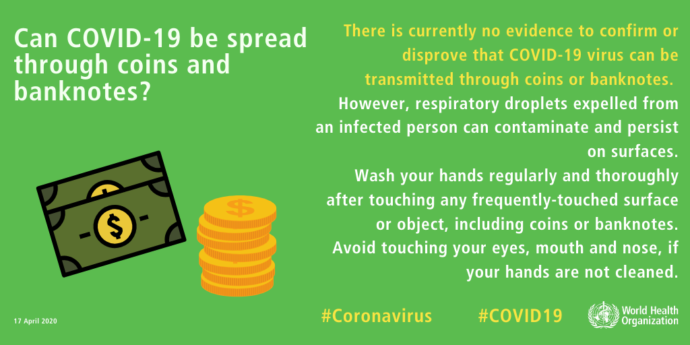
What about the use of cash at the tuck shop and in the school?

Is my child allowed to take lunch to school?

The United States’ Food and Drug Administration (FDA), the World Health Organisation (WHO) and our own government agree that at this stage there is no proof of Covid-19 being spread in food or food packaging. It is well known that several illnesses and viruses can be spread in foodstuff but Covid-19 is not one of them.

It is important to note that learners must maintain social distancing and that food should not be shared if the hands have not been sanitised or properly washed. The person preparing the learner’s packed lunch should be meticulous to ensure that his or her hands are properly sanitised by thorough washing with soap or by a hand sanitiser. Raw and uncooked foodstuff such as fruit should be carefully washed in clean running water.

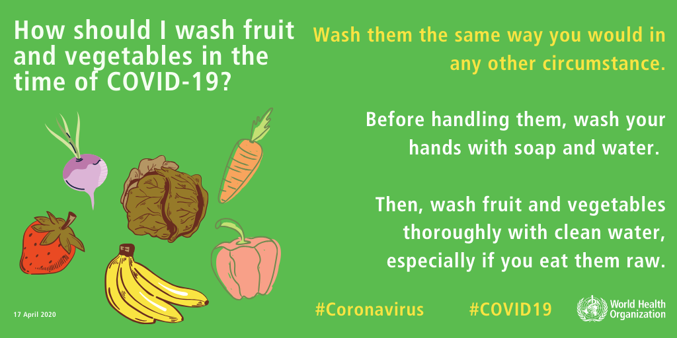

May I refuse to send my child back to school?

On 19 May 2020, the Minister of Basic Education announced that Grade 7 and Grade 12 learners would return to school on 1 June. The announcement of when learners in other Grades would return would be announced at a later date.

Children in the age group 7 to 15 years are subject to compulsory schooling. Section 3 of the SA Schools Act imposes the responsibility on parents to ensure that their children attend school. Schools are required to do all in their power to ensure a safe environment for the learners but schools are under no obligation to support the education of learners who remain at home when schools have re-opened unless the learner suffers from a underlying health condition that may increase the risk of infection with the Covid-19 virus. In that case it is better that the learner remains at home. Learners requiring distance learning arrangements will have to produce medical certificates in support of that request.

Parents are guilty of a transgression of the law and may be subject to prosecution when they keep the child from attending school but do not register their child for home schooling.

The Schools Act stipulates in Section51 that a parent may apply to the Head of Department of the Provincial Department of Education to be allowed to perform home schooling. Upon receipt of permission to conduct home schooling, the learner will no longer be regarded as a learner at a public school. The learner must be registered with a curriculum service provider that can certify the learner for the specific Grade.

Schools may not refuse a parent the right to withdraw a learner from the school. Unless the regulations of the provincial department of education indicate that it must, the school is under no obligation to support the education of the learner who has opted for home schooling. If they wish to retain and not lose learners, schools and School Governing Bodies may wish to consider whether they have the capacity and means to support distance learning.

Learners who were not registered for home schooling have no proof of the year’s academic work and receive no formal certificate. Any school will have the right to assess the quality of the teaching received during the home schooling whether or not a certificate was issued. When a learner wishes to return to a public school for the following year, it will be regarded as a new application subject to the availability of spaces at the school, and its Admission policy. The school has the right to conduct an assessment of the learner’s knowledge and skills to determine the specific Grade most appropriate to the learner. It should not be assumed that that the learner will progress to the next Grade with his/ her age cohort.

Parents are encouraged to seek information from the school before deciding on the possibility of distance learning or home schooling.

ARRANGEMENTS THAT THE SCHOOL WILL IMPLEMENT:

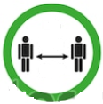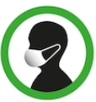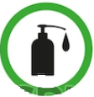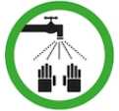
The classroom and school premises are set up to allow for a distancing norm of 1.5m at all times.
There will be monitoring of Staff and learners’ washing of their hands with soap as well as regular hand sanitising.
All visitors, staff members and learners are required to wear some form of covering over their noses and mouths.
Every staff member and learner will be supplied with hand sanitisers, soap and clean water for washing their hands.


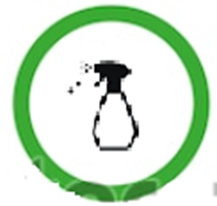

The school premises will regularly be cleaned and sanitised.
Parents will receive ongoing advice regarding new protocols and arrangements that must be implemented.
Relevant protocols will be implemented if staff members or learners have Covid-19 symptoms.
A Learners’ Guide to Returning

I can do the following before returning to school:
- Make sure you have a mask that fits properly.
(It must completely cover your mouth and nose.)
- Practise correctly putting on and removing your mask at home.
(Touch only the elastic bands or strings but do not touch the mask itself on the inside.)
- Practise proper hygiene at home.
(Wash the hands properly and correctly. Cough and sneeze into the inside of your elbow.)
- Practise social distancing of 1.5m.
(Allow no physical contact such as hugs.)
- Eat a healthy diet and maintain good sleeping habits.

How should I wash my hands?

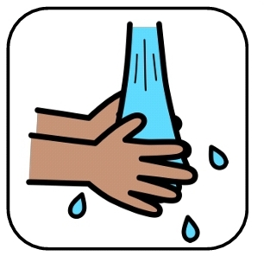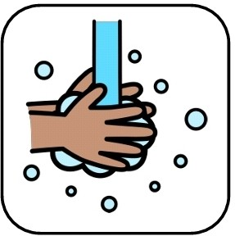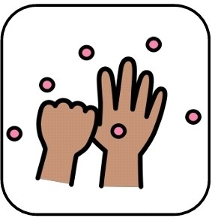

Wet your hands.
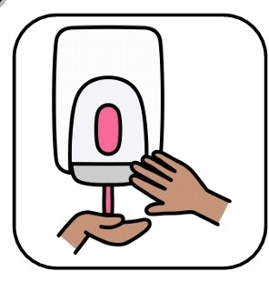
Use soap. Wash the palms and top.

Wash your thumbs..

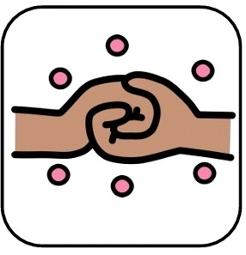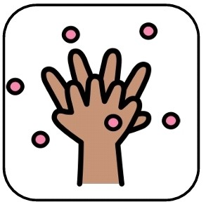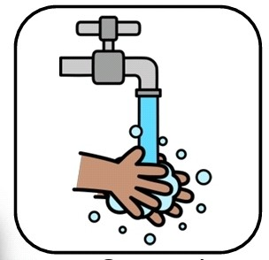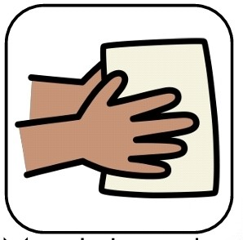

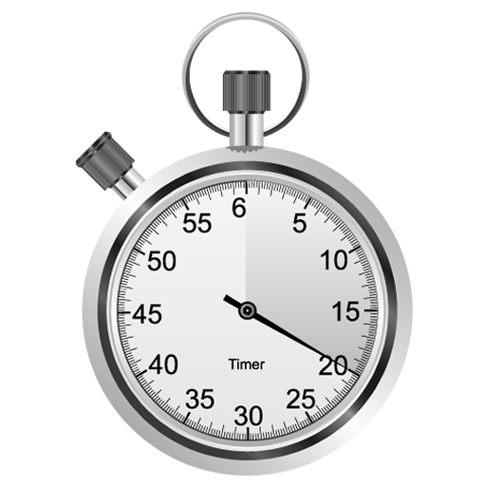
Wash your nails.
Wash your fingers.
Rinse your hands.
Dry your hands. Dispose of paper towel.

Wash your hands for 20 seconds.

Images: www.schooldiva.co.za
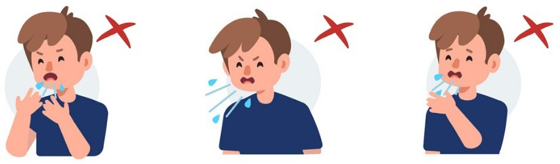
Am I coughing/sneezing in the right manner?
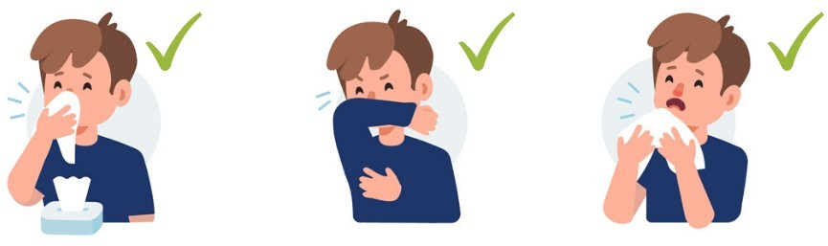

Cough or sneeze into the crook of your elbow.
Cough or sneeze into a paper tissue. Dispose of it immediately.

Emotional wellbeing:

Please speak to your teacher if you’re feeling sad or down.

Children under 18 years are very seldom infected by the Corona virus.

Procedure at the school gate:
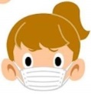
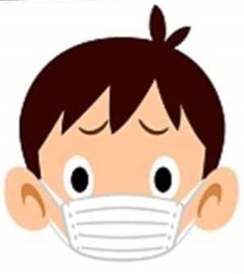
Arrive at school already wearing your mask.


Report to the gate.
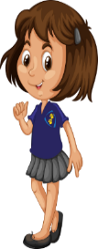
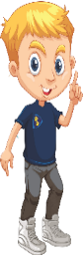
Maintain social distancing of 1.5m at all times.

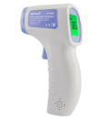
Temperature gets measured.

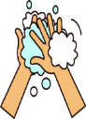
Hands, shoes and bookbag are sanitised.

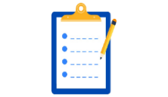
Register and questions are completed.

Questions
Do you have any of the following symptoms?
Temperature > 38ᵒC Yes No
Sudden dry cough Yes No
Shortness of breath Yes No
Sore throat Yes No
Contact with someone
Infected with Covid-19
During the past 14 days Yes No

If you have one or more of these symptoms, unfortunately you may not attend school.

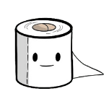
What is different at school?
Ablution procedure:
Wash your hands before and after using the facilities.

No assemblies in the school hall. Virtual assemblies on the whiteboard in the classroom.
No changing of classrooms at the end of lessons.
Alternating breaks – not everyone at the same time.
Bring your own bottle of drinking water from home.
No games involving groups or implements e.g. balls.
Bring your own supply of paper tissues.
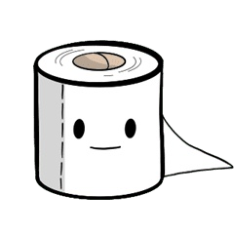
Dry your hands with a paper towel and dispose of it immediately.
When you get back to class, sanitise your hands.
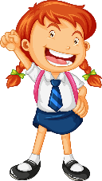

After break:
Report to the hand-washing stand.
Wash your hands thoroughly.
Sanitise hands before entering the classroom.

When you get home, do the following:
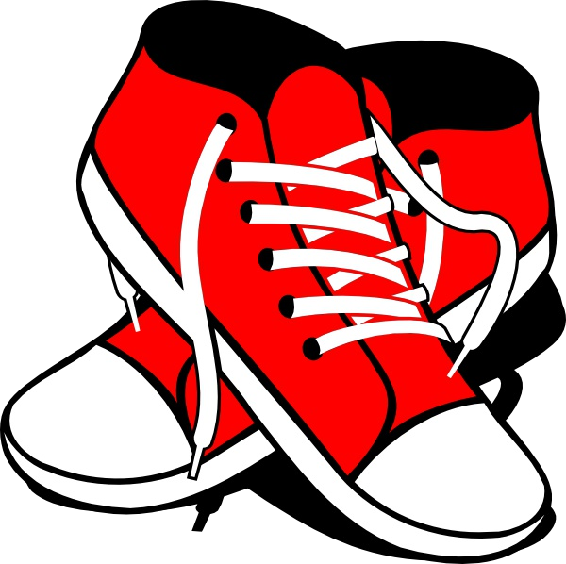

Take off your shoes at the door before going in and leave them there.
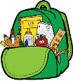
Put your bookbag down just inside the front door.
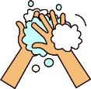
Sanitise your hands.
Remove your mask but touch only the elastic bands or strings.
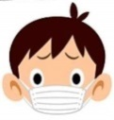
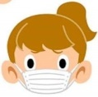
Wash your mask with soap.

Take off your outer clothes and put them in the wash.
Sanitise your hands.

Enjoy a healthy lunch.
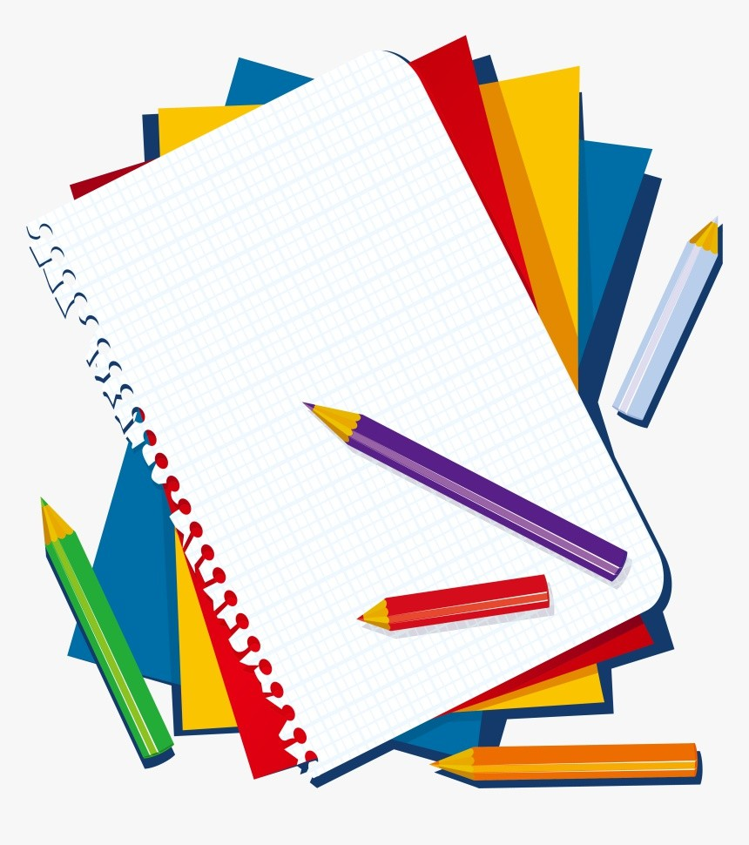
Take out the books you need and do your homework.
Sanitise your hands.

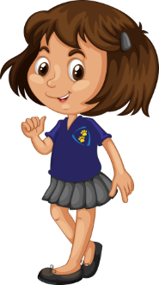

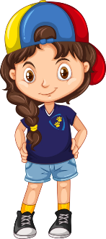
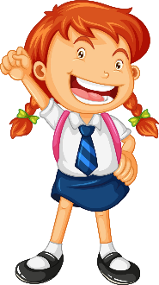
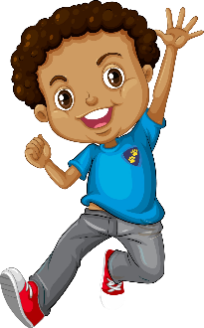

Important information:

Don’t share your mask with anyone.

Wash your mask every day.

Avoid touching your face and eyes.

Don’t share stationery.

Keep your nails clean and short.

Avoid sharing crockery, cutlery, food and drink.

Don’t mock or joke about someone who is ill.

Stay at home if you’re feeling ill.

Inform your teacher if you’re feeling ill at any time during the day.
Thank you!

